USE CASE DIAGRAM AND CASE DESCRIPTION

NAME-SACHREET DHILLON

STUDENT ID-100383292

Team member GITHUB URL- https://github.com/sandhujoban/use-case.git

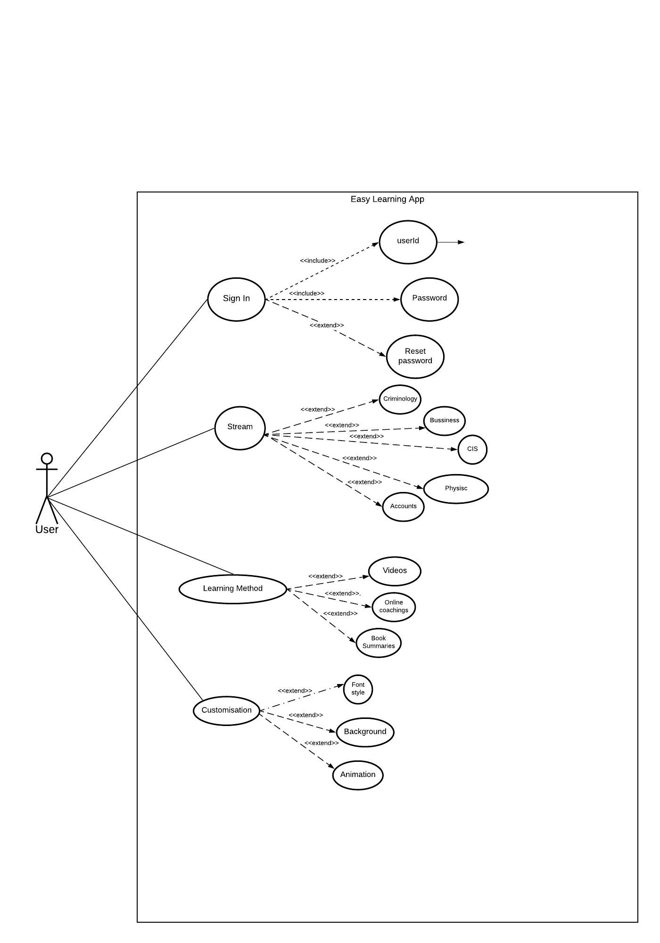

|  |
| --- |
| Use case Title: Easy Learning Techniques |
| Primary Actor: User (students) of the app. |
| Goal: Find crux of learning every tough Topic. |
| Level: Kite Level |
| Preconditions: User must have their userid and Password. |
| Minimal Guarantee: User definitely gets to know the basics of the topic, he is seeking for. |
| Success Guarantee: Perpetuation in Student Knowledge and Horizon. |
| Main Success scenario:  3. User chooses the way by which he is comfortable to learn i.e. Videos, Summaries etc.  As, every question with its solution is available there. Beside this, user makes the look attractive of background. Because it also has a Property of Customisation. |
| Extension  3a. User select one method of learning.  1. Page default error occurs.  3a1.Refresh the page, then page will reload successfully.  3b User selects Multimedia (video) to study.  1. Video do not opened or displayed.  3b1.User try to play video in unsupported browser.  2.User change the browser type and runs successfully. |

**Use case diagram** and **use case description of my team member**

Team- member name-Jobanpreet Kaur

Student ID-100384723

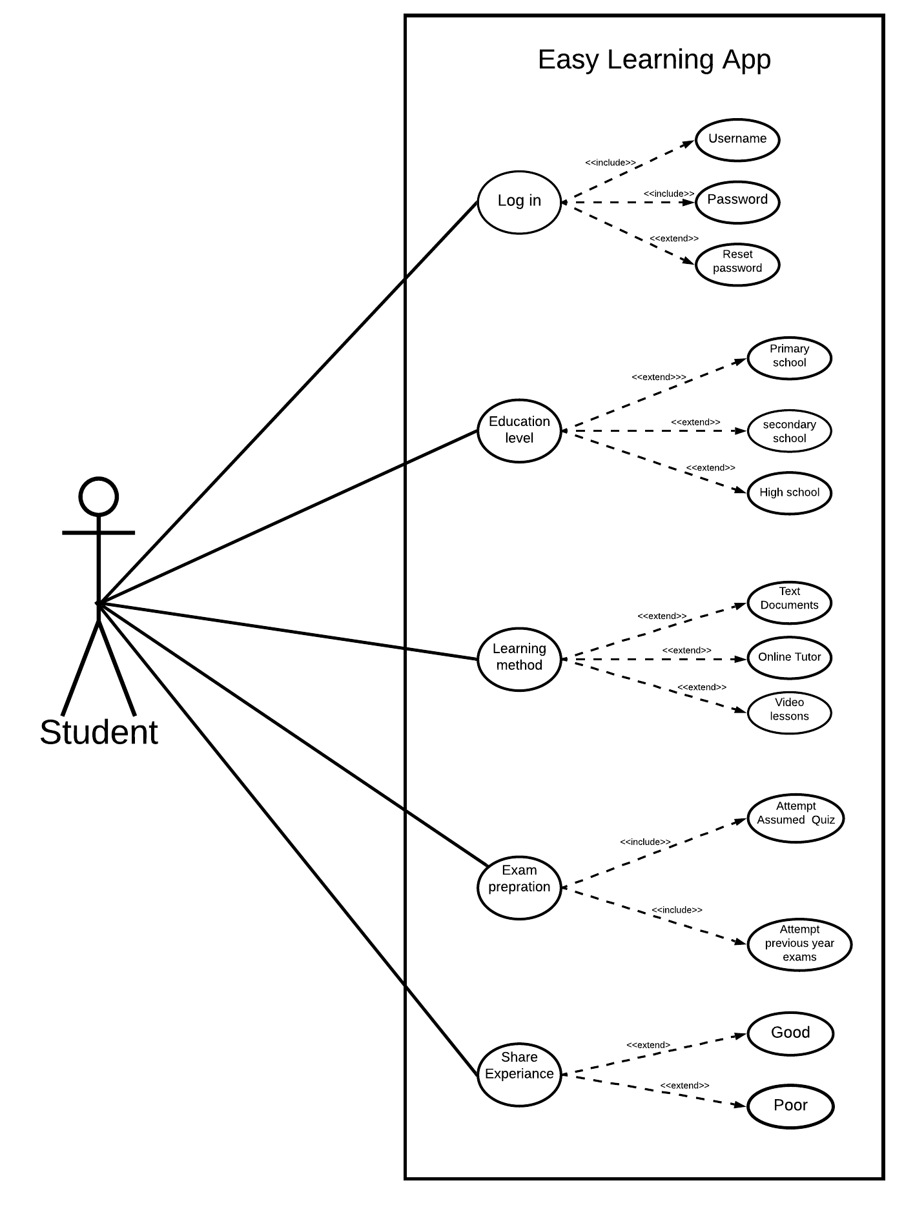

|  |
| --- |
| Use case title: Learning method |
| Primary Actor: Learner |
| Goal: To understand tough topics in easy way for good grades. |
| Level: kite |
| Preconditions: User must have web connection. |
| Minimal Guarantee: If user will follow the guidelines he or she may improve grades. |
| Success Guarantee: If all of the instructions are followed student will experience some changes in grades. |
| Extensions:  3a User select one choice from learning method .   1. Unknown error appear on screen.   3a1. The user may experiencing some fluctuations in web connections.   1. . User click on refresh page and page loads successfully.   3b User select video lessons.   1. . Video can not be played displayed on screen.   3b1. The user could be trying to play the video lessons in unsupported web browser.  2 . User change the web browser and the video plays successfully. |

**REVIEW**

Review of use-case diagram and description

**DIAGRAM ORIGINATOR:Jobanpreet Kaur**

**REVIEWER NAME-Sachreet Dhillon**



**USE-CASE DIAGRAM REVIEW:**

To run the learning app user have to sign in for which username and Password is necessary.In, case if user forget the password. Then he will use its email id to get reset password code.Once, user open the app then he have to choose the level of this course then the method he find interesting to learn.(Online, Text Documents, Videos).In Addition there is a Test to ensure user for the preparation of course. In end this application has an additional feature of Rating.

**REVIEW ON USERCASE DESCRIPTION**

**DESCRIPTION ORIGINATOR=Jobanpreet Kaur.**

**REVIEWER NAME: Sachreet Dhillon**

|  |
| --- |
| Use case title: Learning method |
| Primary Actor: Learner |
| Goal: To understand tough topics in easy way for good grades. |
| Level: kite |
| Preconditions: User must have web connection. |
| Minimal Guarantee: If user will follow the guidelines he or she may improve grades. |
| Success Guarantee: If all of the instructions are followed student will experience some changes in grades. |
| Extensions:  3a User select one choice from learning method .   1. Unknown error appear on screen.   3a1. The user may experiencing some fluctuations in web connections.   1. . User click on refresh page and page loads successfully.   3b User select video lessons.   1. . Video can not be played displayed on screen.   3b1. The user could be trying to play the video lessons in unsupported web browser.  2 . User change the web browser and the video plays successfully. |

LEARNING METHOD REVIEW.

As the Use-case Title reveals this is the use-case description on tips in which the primary Actor is a student or user who wants to learn with a single click of mouse. Moving ahead, the goal is to score well in exams. And also learn everything deeply. To check the preparation there is a quiz in the Tailing of every session .Sometimes if some unknown error occurs just reload or refreshes the page.

FINAL USE CASE DIAGRAM AND DESCRIPTION

We (Sachreet and Joban ) have done the review on use-case diagram and description .After discussion this will be our final use case diagram and description.



USE CASE DESCRIPTION.

|  |
| --- |
| Use case title: Learning method |
| Primary Actor: Learner |
| Goal: To understand tough topics in easy way for good grades. |
| Level: kite |
| Preconditions: User must have web connection. |
| Minimal Guarantee: If user will follow the guidelines he or she may improve grades. |
| Success Guarantee: If all of the instructions are followed student will experience some changes in grades. |
| Extensions:  3a User select one choice from learning method .   1. Unknown error appear on screen.   3a1. The user may experiencing some fluctuations in web connections.   1. . User click on refresh page and page loads successfully.   3b User select video lessons.   1. . Video can not be played displayed on screen.   3b1. The user could be trying to play the video lessons in unsupported web browser.  2 . User change the web browser and the video plays successfully. |